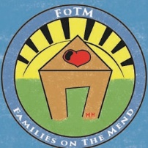

Families on the Mend, LLC.

Adoption Services

POB: 2652

Windermere, Florida 34786

Phone: (407) 476-1334

[Familiesonthemend@gmail.com](mailto:Familiesonthemend@gmail.com)

Necessary Documents for a Home Study

In addition to the forms that have been downloaded, e-mailed, and/or mailed to you, the following forms are needed at or prior to the first home visit:

Birth Certificates for all household members

Marriage Certificates for present and any previous marriages Death or divorce decrees from any previous marriages

Past 2 years tax returns

Copies of health and life insurance policies (the page listing benefits is enough) Current medical exams for each family member (Determined based on health status)

Children: The standard form that the doctor has in the office for school physicals Current vaccination records for any pets

Reference letters: 5 are needed per couple, at least 3 from non-relatives

Driver’s License for all drivers

Social Security Card for all household members

Latest Month’s Paystubs or income verification